**Tender Module**

Tender module will be subscription module basis, where the customer will have following options:-

1. END-TO-END Tender Management system
2. Tender/Bid Publication only

Therefore, for those who will not be subscribing the tender module they can only see list of the tender published in the nexus. There will not be a view button on this page. The view button will be enable for those who subscribe the tender module.

There has be to be high listed section which state, if you want to view more details of the tender please subscribed the tender management system.

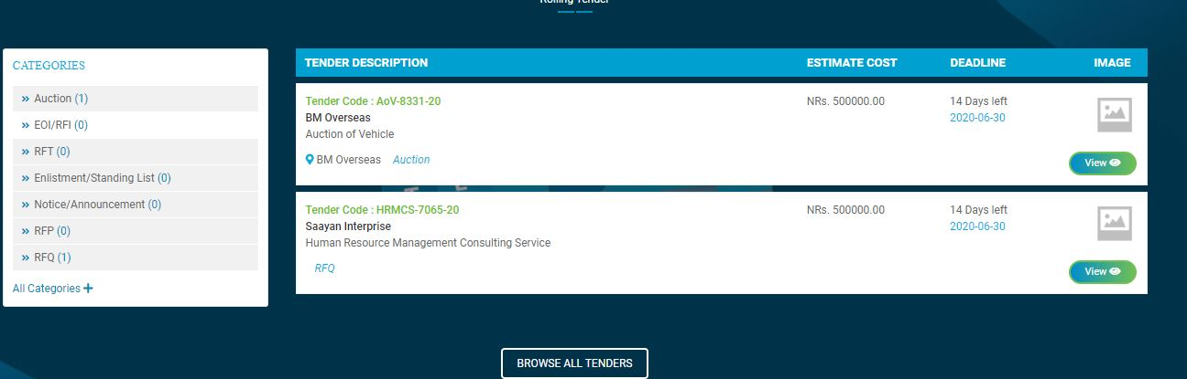

Main page display



Tender Status

Published Date

Need to include Published Date & Tender Status on the main page

After clicking the view button, follow page must be displayed (**Correction to be made on this page is listed below)**

Expression of Interest button

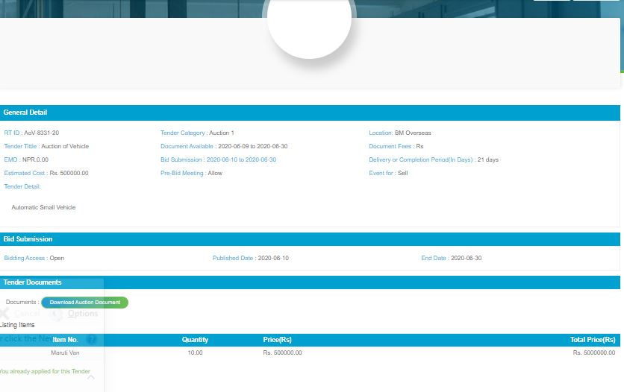

In the business account, **your tender** has to be replaced by **My tender**

**After clicking My tender section, a dashboard will open as below:-**

**Code must be changed as Reference ID which must be before the Bid Title section**

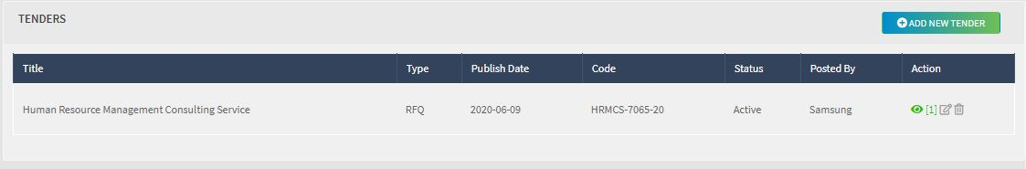

Add deadline section & Tender Status on the tender title section

Your Tender Submission Status

Deadline

**Tender Notice Section**

**Search Options**

Bid Title Reference Number Suppliers name

|  |  |  |  |  |  |  |
| --- | --- | --- | --- | --- | --- | --- |
|  | Bid Title | Deadline | Published on | Organization | Reference ID | Beneficiary Country |
| Expression of Interest |  |  |  |  |  |  |
| Expression of Interest |  |  |  |  |  |  |

Changes to be made on View Page

Bidding Result

Tender Clarification

Tender Evaluation

Tender Submission

Tender Information

General Information

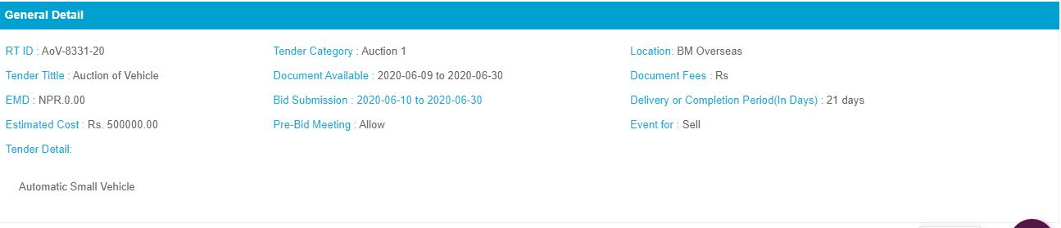

Reference ID

Country Section for International Bid

Deadline for Clarification

Description of Tender

Instead of Bid Submission it should be Deadline date

This is section there should be section where customer can customized their information for the tender, after description of tender there should be questions and answer box as highlighted in

**Tender Specification**

|  |  |
| --- | --- |
| Bidder Scope | Text box |
| Eligibility Criteria of Bidder | Text Box |
| Validity Date of Bid Submission | Text Box |
| Bid Currency | List of Currency |
| Duties and Taxes | Text Box |
| Bid Language | List of Language |
| Evaluation Method | Text Box |
| Evaluation Method Information | Text Box |
| Partial Quotation | Yes/No |
| Terms and Conditions | Text Box |
| Expected Contract Award Date | Date |
| Additional Information | Text Box |

**Documents**

|  |  |  |
| --- | --- | --- |
| File Name | File Type | Date of Publish |
|  |  |  |
|  |  |  |
|  |  |  |

Download all files

All file must be individually clickable & must be open in the assigned format or allow the user to save the file accordingly

**Tender Amendment**

If any Amendment on the tender process, the customer will include those section in this tender amendment portion

**Evaluation Criteria**

|  |  |  |  |
| --- | --- | --- | --- |
| **General Eligibility Criteria** | **Text Box** | **Maximum Point** | **Pass/Fail** |
| **Technical Criteria** | **Text Box** | **Maximum Point** | **Pass/Fail** |
| **Financial Criteria** | **Text Box** | **Maximum Point** | **Pass/Fail** |

**Tender Clarification**

Type your Queries

Reply

There has to be two section on this clarification part, one would be used by the vendor to submit their clarification queries and after their submission, the customer can clarify those question individually. In this section, We need to have a document attachment part.

Tender Submission

Questioners Section | Technical Bid Submission | Quotations Submission | Evaluation Clarification

**Questioners Section**

Type your Questions

Select your answer submission type (Checklist/Textbox/

Add +

**Technical Bid Submission**

This has to be customized page where the customer can designed their proposal submission template by themselves

Two types of Templates:-

**Document Checklist Template**

|  |  |  |  |
| --- | --- | --- | --- |
| Document 1 (Mandatory) | Upload your File | Category | Submitted Date |
| Document 2 (Mandatory) | Upload your File | Category | Submitted Date |
| Document 3 (Mandatory) | Upload your File | Category | Submitted Date |
| Document 4 (Mandatory) | Upload your File | Category | Submitted Date |

Submit

**Completed Document Template**

General Information Section will be displayed

Purpose/Delivery

**Kindly submit your technical proposal here**

**Vendor to submit quotation / estimate on Company Letter Head, duly signed by authorized signatory**

**Submission Content**

**Kindly submit your technical proposal here**

**Vendor to submit quotation / estimate on Company Letter Head, duly signed by authorized signatory**

**Attached Document (Technical Document)**

**Kindly submit your technical proposal here**

**Vendor to submit quotation / estimate on Company Letter Head, duly signed by authorized signatory**

**Attached Document (Others Document)**

Submit

**Quotations Submission**

General Information Section will be displayed

Purpose/Delivery

**Kindly submit your technical proposal here**

**Vendor to submit quotation / estimate on Company Letter Head, duly signed by authorized signatory**

**Submission Content**

**Kindly submit your technical proposal here**

**Vendor to submit quotation / estimate on Company Letter Head, duly signed by authorized signatory**

**Attached Document (Financial Document)**

**Kindly submit your technical proposal here**

**Vendor to submit quotation / estimate on Company Letter Head, duly signed by authorized signatory**

Submit

Or

**Document Checklist Template**

|  |  |  |  |  |
| --- | --- | --- | --- | --- |
| Document 1 (Mandatory) | Upload your File | Total Financial Offer Details | Category | Submitted Date |
| Document 2 (Mandatory) | Upload your File | Total Financial Offer Details | Category | Submitted Date |
| Document 3 (Mandatory) | Upload your File | Total Financial Offer Details | Category | Submitted Date |
| Document 4 (Mandatory) | Upload your File | Total Financial Offer Details | Category | Submitted Date |

Submit

Evaluation Clarification

Type your Queries

Reply

There has to be two section on this clarification part, one would be used by the vendor to submit their clarification queries and after their submission, the customer can clarify those question individually. In this section, we need to have a document attachment part.

**Bid Result**

**Search Options**

Bid Title Reference Number Suppliers name

|  |  |  |  |  |  |
| --- | --- | --- | --- | --- | --- |
| Bid Title | Vendor | Award Date | Organization | Reference ID | County |
|  |  |  |  |  |  |
|  |  |  |  |  |  |

Tender Alert Service (This has to be enable in the business account section of the customer)

Receive new and revised tenders matching your products and services via email

Front Page Tender Display Module

Advance Search Options Here



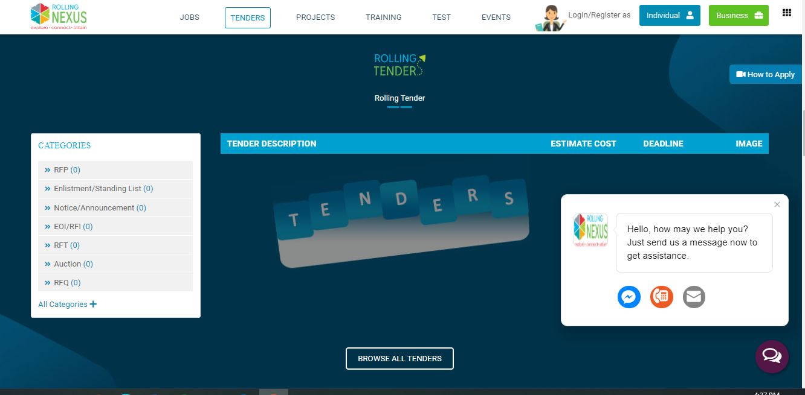

English & Nepali selection will allow to do the advance search based on the English and Nepali Date (User friendly on accessing details of tender)

Search option to be placed

For English

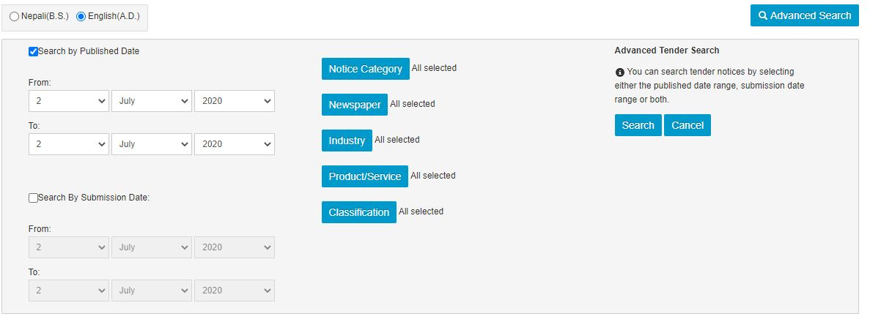

For Nepali

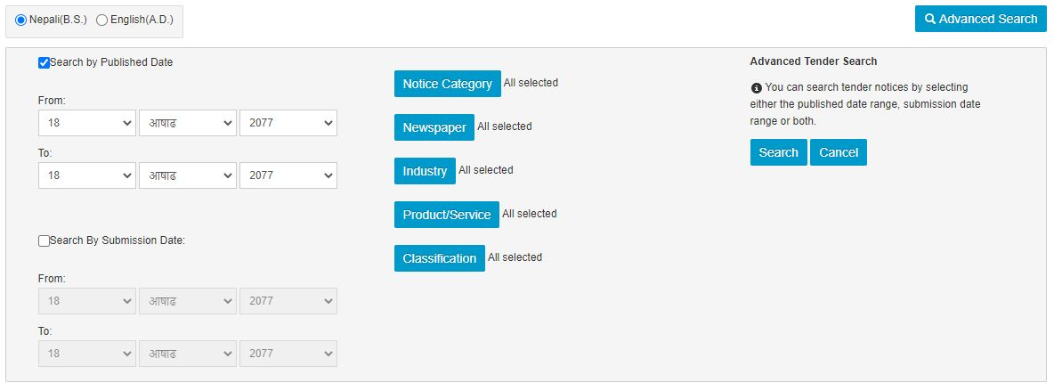

We don’t need to copy the design as above similar to this can be built for our module

Image

Number of Days Left

Newspaper

Categories

Deadline

Published Date

Tender Descriptions

Notice Publisher



New Front Page Look like this

Rolling

Nexus

Let’s put the categories part in the search options along with Notice Category, Newspaper, Organization/Industry Type/Notice Classification





Notice Publisher

Tender Description

Date of Publication

Deadline

Notice Category

Organization /Industry Type

Newspaper

No. of Days Left

Image

Notice Classification

Rolling Plans Private Limited

HR Consulting Service

July 2, 2020

July 30, 2020

RFP

HR Consulting Firm

Kantipur

26

Image

Job related service

Rolling Plans Private Limited

HR Consulting Service

July 2, 2020

July 30, 2020

RFP

HR Consulting Firm

Kantipur

26

Image

Job related service

Rolling Plans Private Limited

HR Consulting Service

July 2, 2020

July 30, 2020

RFP

HR Consulting Firm

Kantipur

26

Image

Job related service



To view more details of the tender, please subscribe Rolling Tender!!

**List of all search options**

|  |  |  |  |
| --- | --- | --- | --- |
| Notice Category | Newspaper | Organization/Industry type | Notice Classification |
| Amendment Notice | Aarthik Dainik | Accounting/ Auditing | Auction Notice |
| Auction | Aviyan | Architectural | Bank Defaulter Notice |
| Enlistment | Gorkhapatra | Hydro power/Energy | Classified Notice |
| Letter of Intent (LOI) | Himalayan Times (English) | Arms/Defense/police | Job Related Notice |
| Pre-Qualification | Janata Post | Banking/Finance/Insurance | Linked Notice |
| Quotation | Karobar | Communication/Telecommunications | Private Notice |
| Re-quotation | Nagarik | Consulting | Rent Related Notice |
| Standing List | Nepal Samacharpatra | Electronics/Electric Utilities | Share/Stock related Notice |
| Tender | Rajdhani | Government/Ministries/Departments | Award Notice |
| Time Extension | The Rising Nepal | IT/Computer Software | Buying Notice |
| Application | Annapurna Post | Manufacturing | Contract Notice |
| Award Notice | Himalaya Times (Nepali) | Movies/Music/Entertainment | Legal Notice |
| Expression of Interest (EOI) | Commander Post | Office Supplies/Stationeries | Other Notice |
| Notice | PPMO | Real Estate | Public Notice |
| Proposal | Janasawal | Sports | Selling Notice |
| Request for Proposal (RFP) | Kantipur | Trade/Retails & Wholesale |  |
| Request for Quotation (RFQ) | Madhyanha Dainik | Advertising |  |
| Short Listing Notice | Naya Patrika | Furnitures/fixtures |  |
| Technical and Financial Proposal | Online Patrika Dainik | Agriculture |  |
| Tender/Quotations | Prabhab | Automotive/Vehicles |  |
|  | Republica | Clothing/Textile |  |
|  | The Kathmandu Post | Construction/Building/Contracting |  |
|  |  | Education-Colleges, Universities & Schools |  |
|  |  | Food/Beverage & tobacco |  |
|  |  | Health/Medical/hospital |  |
|  |  | Legal |  |
|  |  | Media/Newspaper/Printing |  |
|  |  | Non profit |  |
|  |  | Other Industry |  |
|  |  | Security |  |
|  |  | Tourism/Hotel/Travel/Airline |  |
|  |  | Utility Service |  |
|  |  | Others |  |